**Tutorial 11 B+ ( week 7-12 NOV 2022 )**

# Q1. Construct a B+Tree of order=3 using the data R,Y,F,X,A,M,C,D,E,T,H,V,L,W,G.

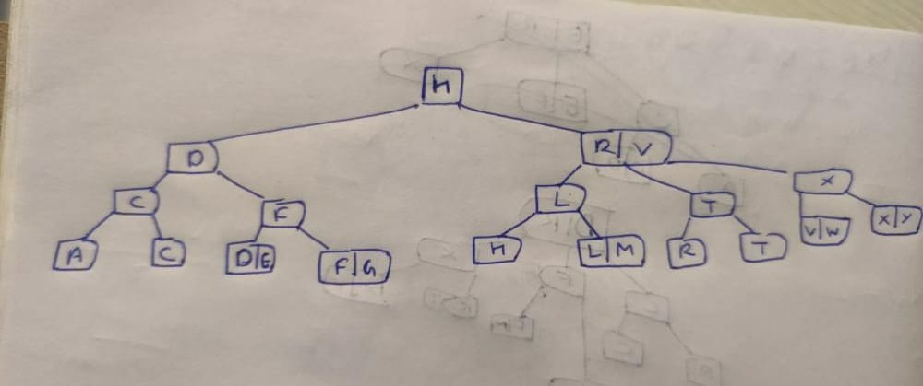

Q2. What are the advantages of using B+ tree over B Tree.

B+ Tree is an extension of B Tree which allows efficient insertion, deletion and search operations.

In B Tree, Keys and records both can be stored in the internal as well as leaf nodes. Whereas, in B+ tree, records (data) can only be stored on the leaf nodes while internal nodes can only store the key values.

The leaf nodes of a B+ tree are linked together in the form of a singly linked lists to make the search queries more efficient.

B+ Tree are used to store the large amount of data which can not be stored in the main memory. Due to the fact that, size of main memory is always limited, the internal nodes (keys to access records) of the B+ tree are stored in the main memory whereas, leaf nodes are stored in the secondary memory.